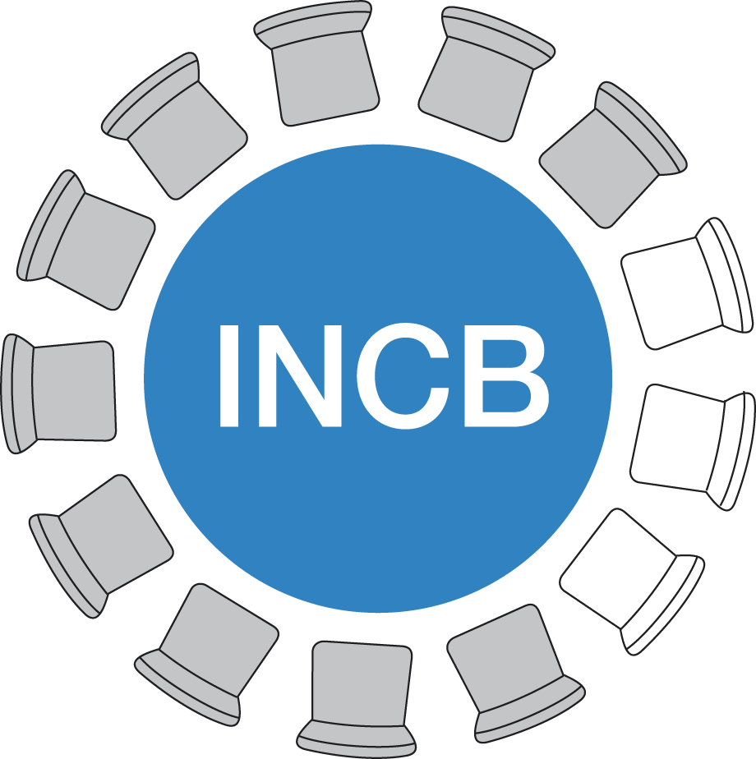 | International Narcotics Control Board | NOTIFICATION  on seizures of internationally controlled licit substances ¹ smuggled through the mail,  including those ordered via the Internet

In accordance with the Commission on Narcotic Drugs (CND) resolution 50/11 (2007)

Country or Territory: |  | Date:
Competent office:
Title or function:
Responsible officer’s name: |  | Email:
Telephone number(s): |  | Fax number(s):
Signature: |  | Calendar year :

Seizures of consignments
(NB: Should all the required information not be available, partial information would also be welcome)
Name of controlled substance seized | Number of seizures | Total quantity of the controlled substance seized ² | Sources of the  consignments seized ³ | Mail delivery providers  involved ⁴ | Relevant information  if Internet sites were  identified as sellers ⁵
Explanatory notes:

- Pharmaceutical preparations containing internationally controlled substances: Narcotic drugs, as listed in the Single Convention on Narcotic Drugs 1961, psychotropic substances, as listed in the 1971 Convention on Psychotropic Substances and precursors, as tabled in the United Nations Convention against Illicit Traffic in Narcotic Drugs and Psychotropic Substances, 1988.
- Please indicate the unit of measurement (kg, g or mg).
- Countries / territories of origin of mail.
- Please indicate state postal systems or private courier service companies most frequently involved.
- Please indicate details on websites most frequently identified as sellers (e.g. company name, contact details, domain name). March 2011 edition
This form can be downloaded from the INCB website http://www.incb.org/.

