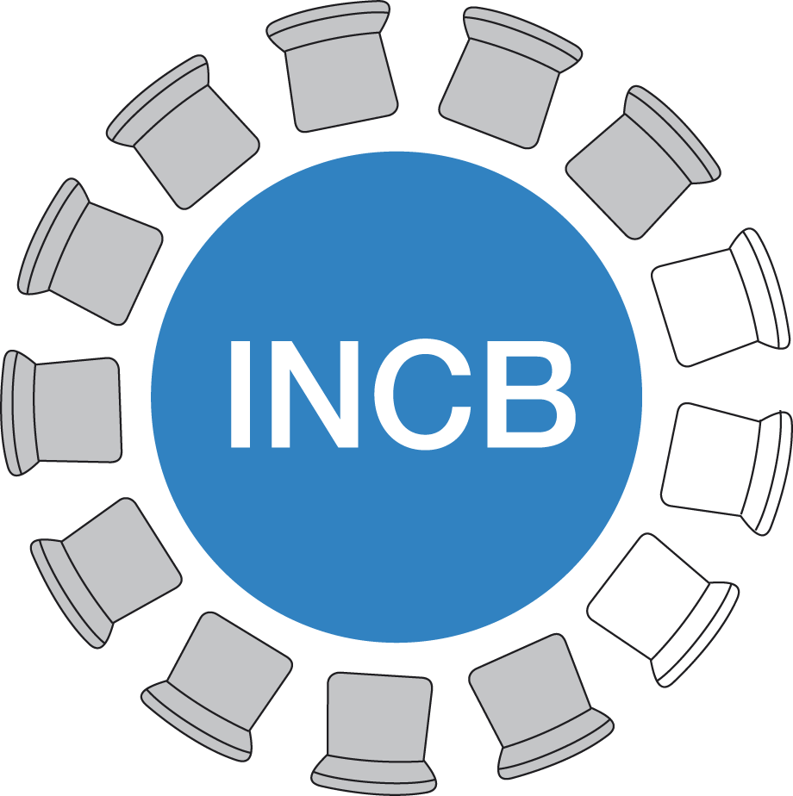
International Narcotics Control Board Supplement to FORM B/P

SUPPLEMENT TO THE ASSESSMENT OF ANNUAL MEDICAL AND SCIENTIFIC REQUIREMENTS FOR SUBSTANCES
IN SCHEDULES II, III AND IV OF THE CONVENTION ON PSYCHOTROPIC SUBSTANCES OF 1971
(to be furnished to the International Narcotics Control Board (INCB) pursuant to
Economic and Social Council resolutions 1981/7, 1991/44, 1993/38 and 1996/30)
Country or territory: |  | Date:
Competent office: |  | Title or function:
Responsible officer’s name: |  | Signature:
Telephone number(s):

Code* | Substance | Quantity** |  | Remarks
 |  | Kg | g
* Substance codes as included in the list of psychotropic substances under international control entitled “Green List”.
** Quantity to be added to (+) or to be deducted from (-) the previously submitted assessments.

Note:
1. This form may be used to submit a supplement to the current assessments.
2. The new total assessments will replace the quantities indicated in previous submissions of Form B/P and any subsequent modifications to those submissions.
3. Competent authorities are encouraged to provide an explanation of the circumstances necessitating the revision under the “Remarks” column.
4. Quantities of psychotropic substances to be exported should not be included.
V.18-02468 (E)
*1802468*

